# 题目

给你一个二维整数数组matrix，返回matrix的转置矩阵。

矩阵的转置是指将矩阵的主对角线翻转，交换矩阵的行索引与列索引。

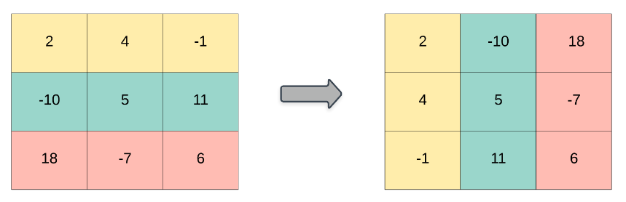

示例 1：

输入：matrix = [[1,2,3],[4,5,6],[7,8,9]]

输出：[[1,4,7],[2,5,8],[3,6,9]]

示例 2：

输入：matrix = [[1,2,3],[4,5,6]]

输出：[[1,4],[2,5],[3,6]]

提示：

m == matrix.length

n == matrix[i].length

1 <= m, n <= 1000

1 <= m * n <= 10^5

-10^9 <= matrix[i][j] <= 10^9

# 分析

## 方法一：模拟

class Solution {

public:

vector<vector<int>> transpose(vector<vector<int>>& matrix) {

int m = matrix.size(), n = matrix[0].size();

vector<vector<int>> transposed(n, vector<int>(m));

for (int i = 0; i < m; i++) {

for (int j = 0; j < n; j++) {

transposed[j][i] = matrix[i][j];

}

}

return transposed;

}

};